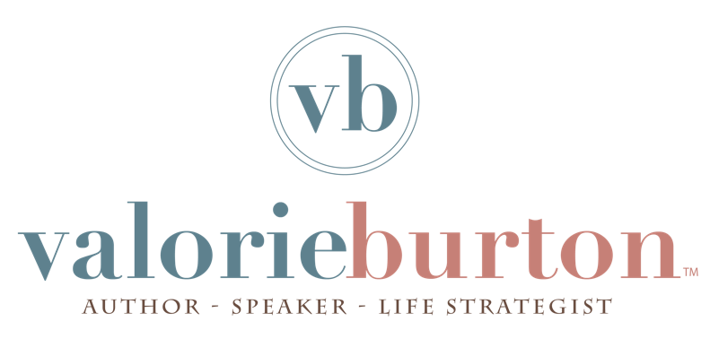

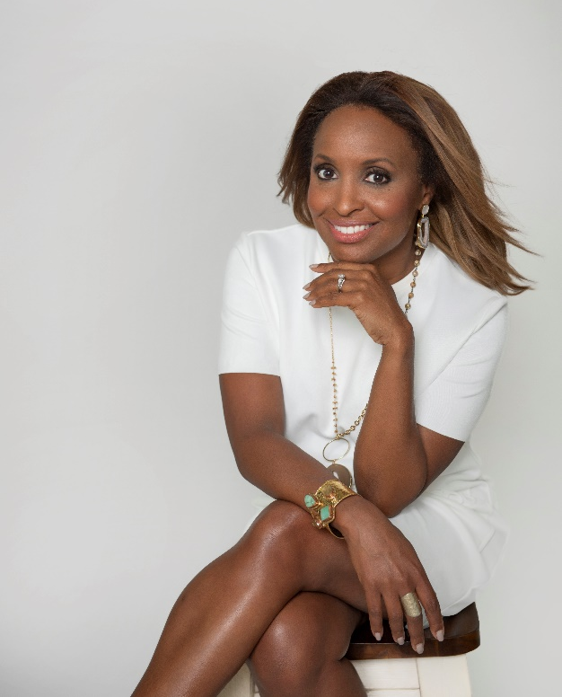
National bestselling author, international speaker and life strategist Valorie Burton is the founder and CEO of the Coaching and Positive Psychology (CaPP) Institute.
Valorie has been a regular guest expert on Today Show, O Magazine, CNN, NPR and Dr. Oz. She has spoken for hundreds of organizations around the globe such as Google, Apple, Coca-Cola, NASA, Chick-fil-A and LinkedIn. Her life-changing messages have an intriguing, research-based emphasis in the pioneering field of applied positive psychology – the study of what happens when things go right with us.
She was named one of the top 60 motivational speakers in America, one of the Top 100 Thought Leaders in the field of personal development and featured in Ebony Magazine’s “Power 100” List. In 2020, two of her books received the Bronze Award from the Evangelical Christian Publishers Association, an honor bestowed upon high-quality books that are among the top-selling books in the last decade.
Her company, The CaPP Institute, provides coaching, coach training, and resilience training to people all over the world and has served clients in all 50 states and 25 countries around the world.
Since 1999, she has written 13 books on personal development, translated into nine languages, including the bestsellers Successful Women Think Differently, Successful Women Speak Differently, What’s Really Holding You Back?, and her most recent book Let Go of the Guilt.
Valorie grew up in an Air Force family, living in Florida, Germany and Colorado, and spent her summers down south with her grandparents in Anderson, South Carolina. Her career began in Dallas, where she ran a public relations firm, co-hosted the television show The Potter’s Touch with T.D. Jakes, and was the youngest person appointed to the Texas Governor’s Commission for Women. She moved to Atlanta in 2009 to be near family in a city she had always admired.
She has a master’s degree in applied positive psychology from the University of Pennsylvania, a master’s degree in journalism from Florida A&M University and a BA from Florida State University. She and her husband Jeff live south of Atlanta with their children. Get inspired with her videos, podcast and writing online at www.valorieburton.com.

